**BJT Characteristics**

**Input Characteristics**

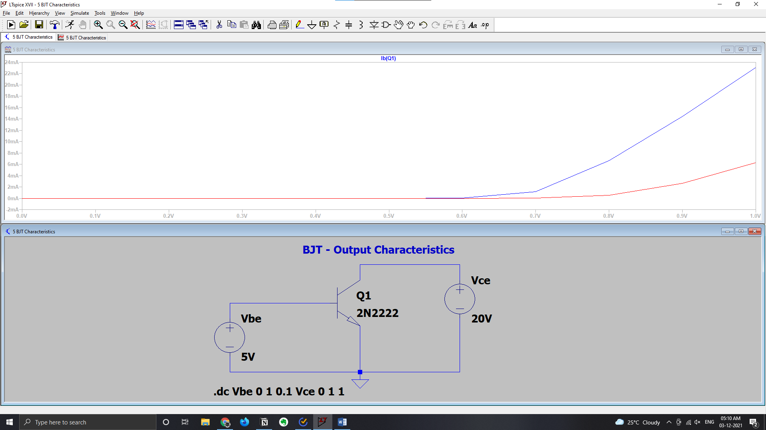

**Output Characteristics**

